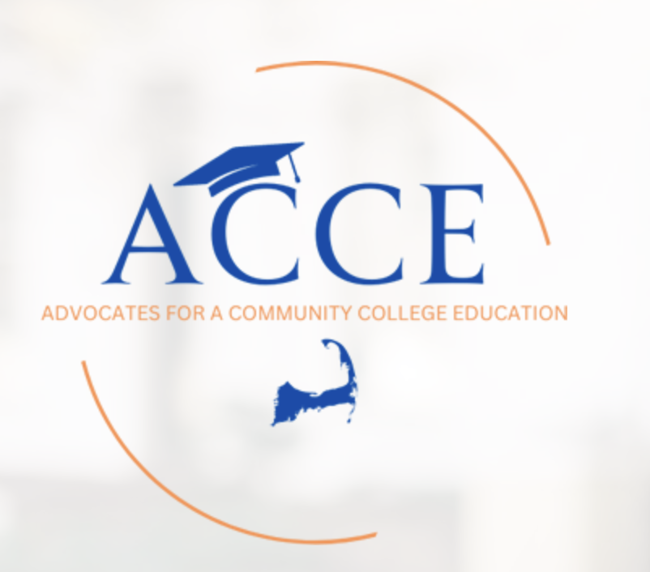
ACCE MENTORING SCHOLARSHIP APPLICATION 2025
Application Deadline is Tuesday, April 1, 2025
This application must be accompanied by:
- Two references - adults at school (teacher, counselor or coach) who know you best and can speak to your interest in continuing your education and your desire for mentoring
- Official high school transcript
- Two-part essay (approximately 100 words each part) describing: a) a challenge you’ve faced and how you handled it and b) your main strength and weakness and how you think mentoring will help you
Please note that it is important to submit all required information since missing data may be an obstacle to selection.

ABOUT ACCE MENTORING
The single most important and unique element of ACCE's approach to continuing education is to provide mentoring for recipients of our scholarships. We know that research confirms the powerful positive impact of quality mentoring relationships on young people as they pursue their goals, and we take seriously the opportunity to be part of their journey. We guarantee our ACCE students will receive guidance, coaching and encouragement during the entire term of their scholarship through personal relationships with mentors who meet with them regularly. Those mentor meetings include non-judgmental discussion of goals, progress, and challenges in a safe, positive environment based on each student's individual situation and experience. Mentors understand that their role isn't to solve a student's problems but to use their experience, insight and expertise to ask questions and offer suggestions and coaching to help students learn and move forward independently. Our mentors are committed to the student's successful navigation of the high school to college transition and to ongoing growth, development and academic success. ACCE students matter to us and we care about them.

PERSONAL
Name
Address
Date of birth
Cell phone (calling and texting)
Personal email
High School

EDUCATION GOALS
Academic Program or Major (if decided)
Work or career objective after finishing college

FAMILY
Parent(s) or Guardian(s) name
Parent(s) or Guardian(s) Address
Parent(s) or Guardian occupation(s)
# of siblings (brothers and sisters)
Family members who attended or are attending college
Describe any regular responsibilities you have within your family

FINANCIAL
Have you completed a FAFSA or MAFSA application? | FAFSA _____Yes No______ MAFSA ______Yes _____NO
Amount you and/or your family will contribute to the cost of college each semester?
What additional sources of money are you relying on to pay for unexpected expenses?
Will you be working while attending college?
How many hours per week do you plan to work?

HIGH SCHOOL AND COMMUNITY ACTIVITIES (Teams, Committees, Leadership positions, Recognition received)
Please list all of your extracurricular activities
Year  From - To | Your Role / Responsibility | List of Your Activities

STUDENT EMPLOYMENT HISTORY (Employers, Dates, Positions, Hours per week)

Dates  From - To | # of Hours Per Week | Employer | Position /Title

SPECIAL CIRCUMSTANCES
Please describe any special personal or financial circumstances you would like the committee to consider.

Applications will be received and reviewed by the ACCE scholarship committee. Students identified as possible scholarship recipients will be interviewed by ACCE members. A final decision will be made by the ACCE scholarship committee.
Scholarship funds are sent to directly from ACCE to Cape Cod Community College in payment for classes in which a student has registered; no funds are sent to students.

Two-part essay (approximately 100 words each part)
A). Describe a challenge you’ve faced and how you handled it.

B) Describe your main strengths and weaknesses and how do you think mentoring will help you

Teacher / Guidance Counselor Recommendations
- Two references - adults at school (teacher, counselor or coach) who know you best and can speak to your interest in continuing your education and your desire for mentoring

Teacher Name / Title
Email Address |  | Phone Number:
School
School Address

Teacher Recommendation:

Teacher / Guidance Counselor Recommendations
- Two references - adults at school (teacher, counselor or coach) who know you best and can speak to your interest in continuing your education and your desire for mentoring

Teacher Name / Title
Email Address |  | Phone Number:
School
School Address

Teacher Recommendation:

